Class A amplification:

* 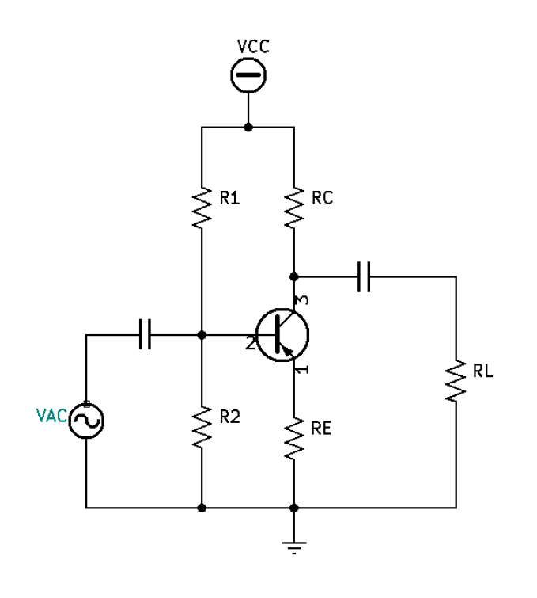Transistor Amplification is active for 360 $°$ of the input cycle (always on – DC current).
* 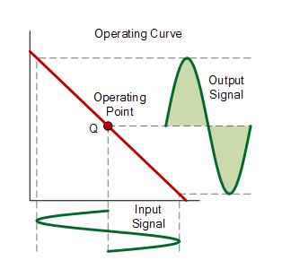Achieves a highest degree of linearity

${Efficiency}_{class A}=\frac{P_{out}}{P_{Consumed}}≈\frac{P_{RL}}{IC×VCE}$

${MaxEfficiency}_{class A}≈25\%$

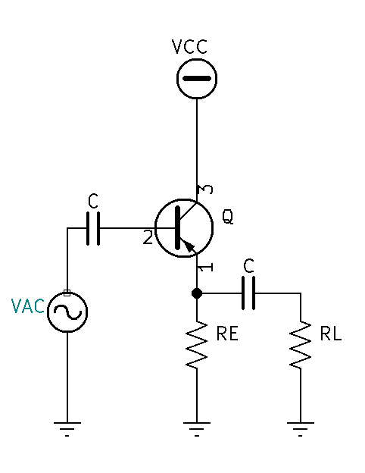Class B amplification:

* Transistor Amplification is active for nearly 180 $°$ of the input cycle (on nearly $50\%$ of the time).

${MaxEfficiency}_{class B}≈50\%$

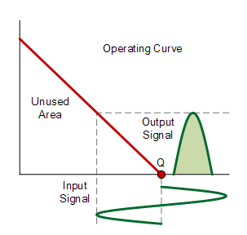

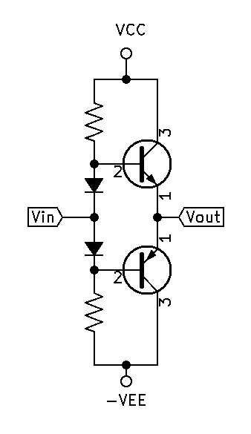Class AB amplification:

* Transistors are never on at the same time.
* Transistor Amplification is active for each transistor nearly 180 $°$ of the input cycle (on nearly $50\%$ of the time). This means that nearly 360 $°$ of the input signal is amplified.
* Crossover distortion occurs when both transistors are off.
* Achieves a high degree of linearity

${MaxEfficiency}_{classAB}≈50\%$

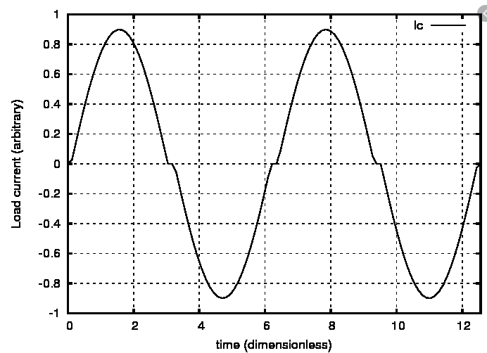

Class C amplification:

* Transistor Amplification is active less than 180 $°$ of the input cycle (less than $50\%$ of the time).
* Commonly uses: high frequency sine-wave oscillators & radio frequency amplifiers
* Achieves a low degree of linearity

${MaxEfficiency}_{classC}≈75\%$

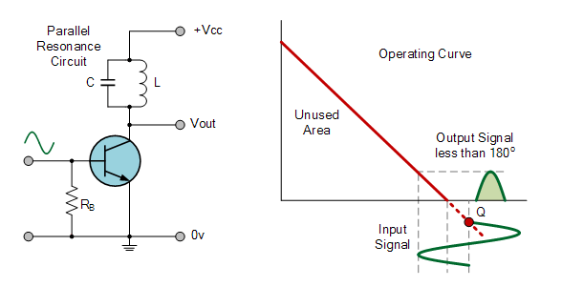

Class D amplification:

* Non-linear switching amplifier or PWM amplifier.
* No period during a cycle where the voltage and current waveforms overlap.

${MaxEfficiency}_{classC}≈100\%$

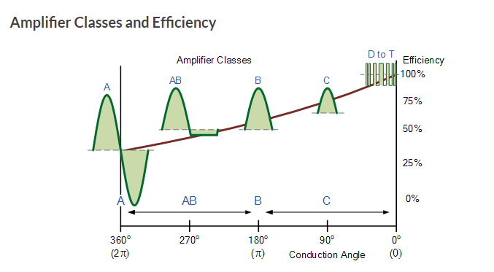

References:

“Amplifier Classification and Efficiencies.” *Amplifier Classes*, www.electronics-tutorials.ws/amplifier/amplifier-classes.html.

*Cross-over Distortion Image*. www.researchgate.net/profile/George_Slade/publication/263115807/figure/fig7/AS:669483857350667@1536628798367/Class-B-push-pull-load-current-showing-crossover-distortion-near-zero-crossing-points.ppm.